DEPARTMENTAL ACTIVITIES 2022-23

EVENT REPORT
Seminar on Language and Identity in the Ardhakathanaka of Banarsidas.
SEPTEMBER 22, 2022

Prof. Haider highlighted the importance of the Ardhakathanak- the first biography written in the vernacular by a merchant named Banarsidas, using three major Hindvi dialects- Braj, Awadhi and Khariboli. He emphasized on how individuality and identity are crucial issues in the various episodes and anecdotes narrated by Banarsidas and the way the text reflects on the myriad complexities of human nature and society of the times.
Prof. Khurshid Khan from the department chaired the lecture. The History faculty, colleagues from other disciplines along with approximately hundred and fifty students from diverse courses attended the Seminar. Vineet Gupta - an alumnus of the department, pursuing Ph.D. from University of Vanderbilt, USA also joined.
In the interactive session after the lecture the audience especially the students addressed numerous insightful queries and doubts to the speaker.
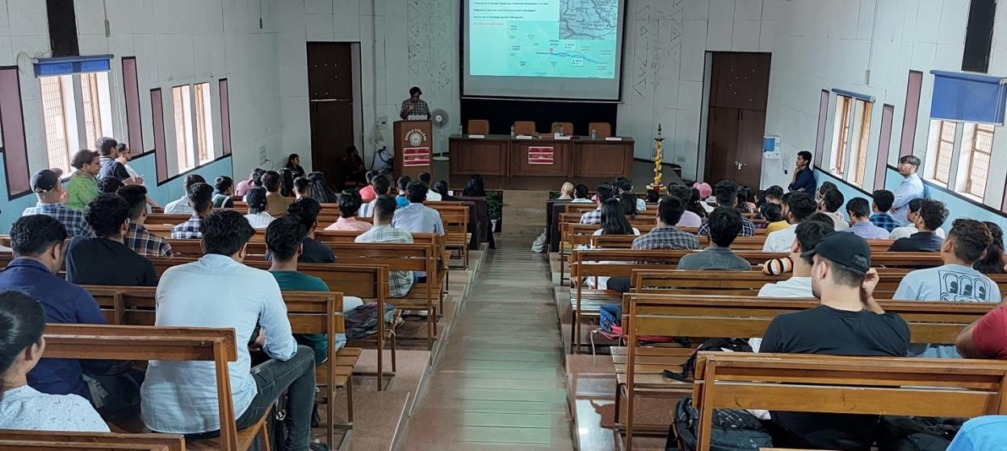

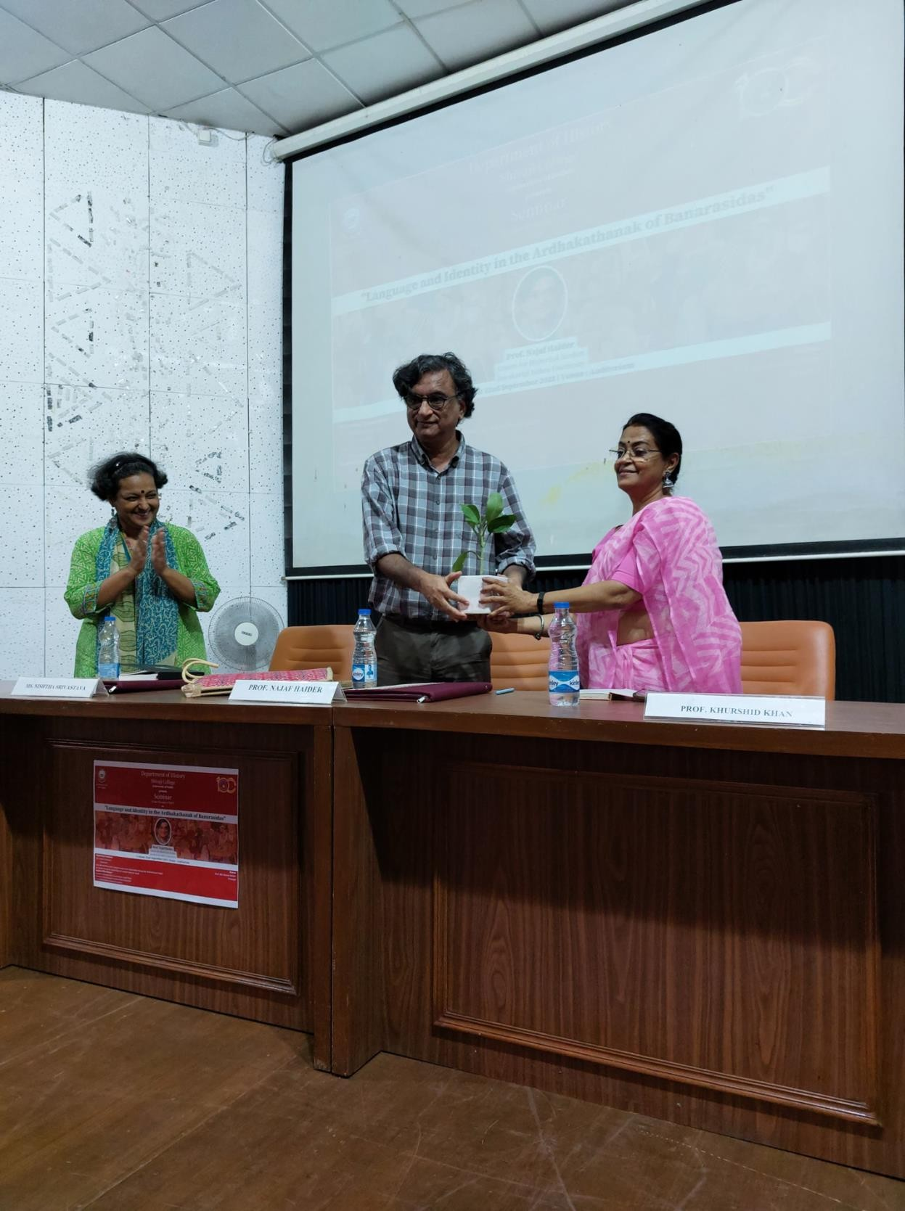

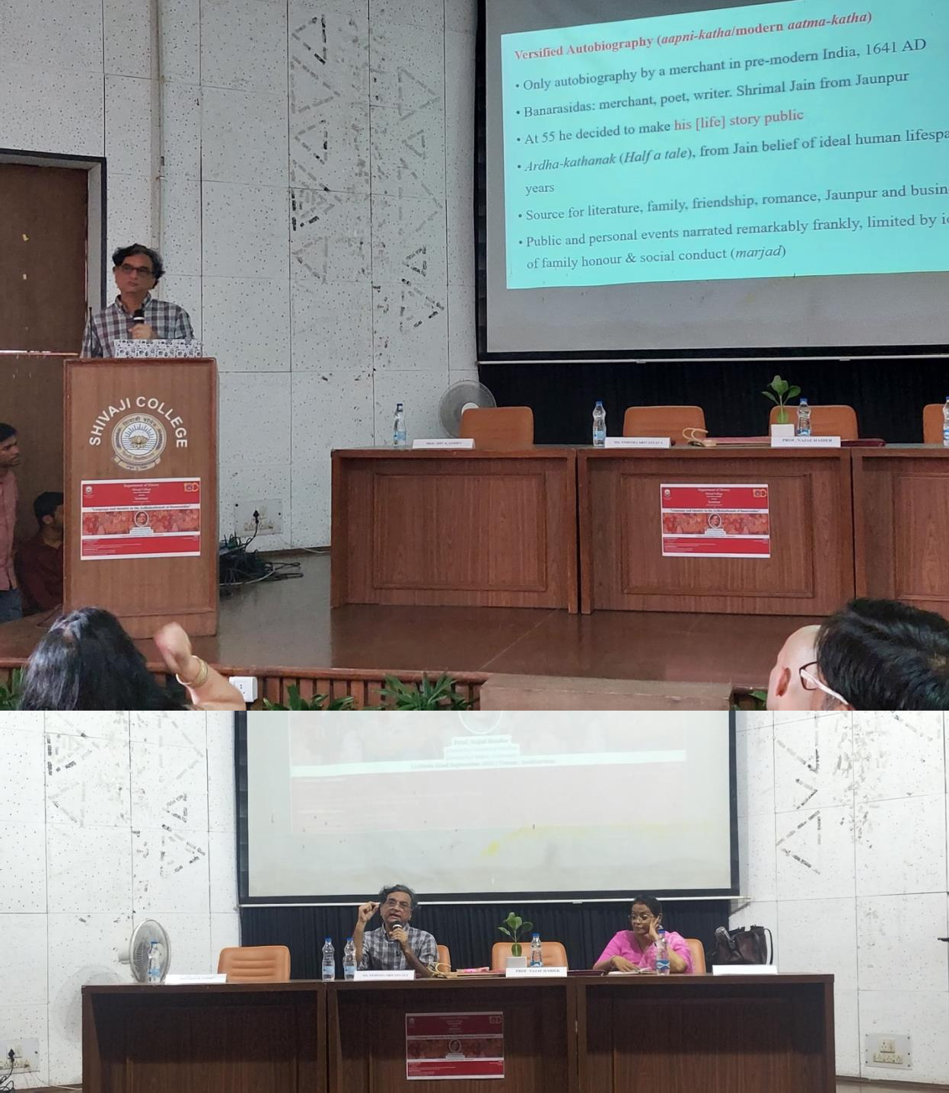
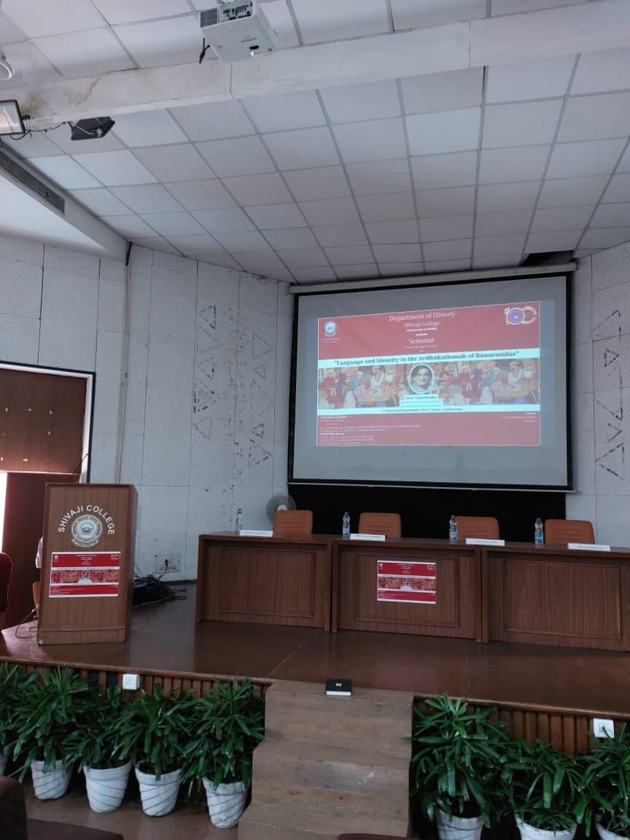

REPORT
ORIENTATIO/INDUCTION OF FIRST YEAR STUDENT of HISTORY
NOVEMBER 2, 2022

The Department organized an orientation/induction programme of the first year students. The Teacher-in-charge, Ms. Nishtha Srivastava welcomed the first-year students giving an insight about the discipline, its pedagogy and activities of the department at length. Prof. Shama Mitra Chenoy, Prof. Amarjiva Lochan and Mr. Skand Priya, the teachers of the first years, acquainted the students with the papers that they would be engaging with and the academic schedule that would to be followed. Prof. Khurshid Khan, Dr. Kundan, Dr. Sarvjeet and Dr. Sonal informed the students about the facilities and opportunities that the department and college offered and how to benefit from those. The faculty stressing on regular class attendance, motivated students to work hard and achieve success. The session concluded with the distribution of the timetable.

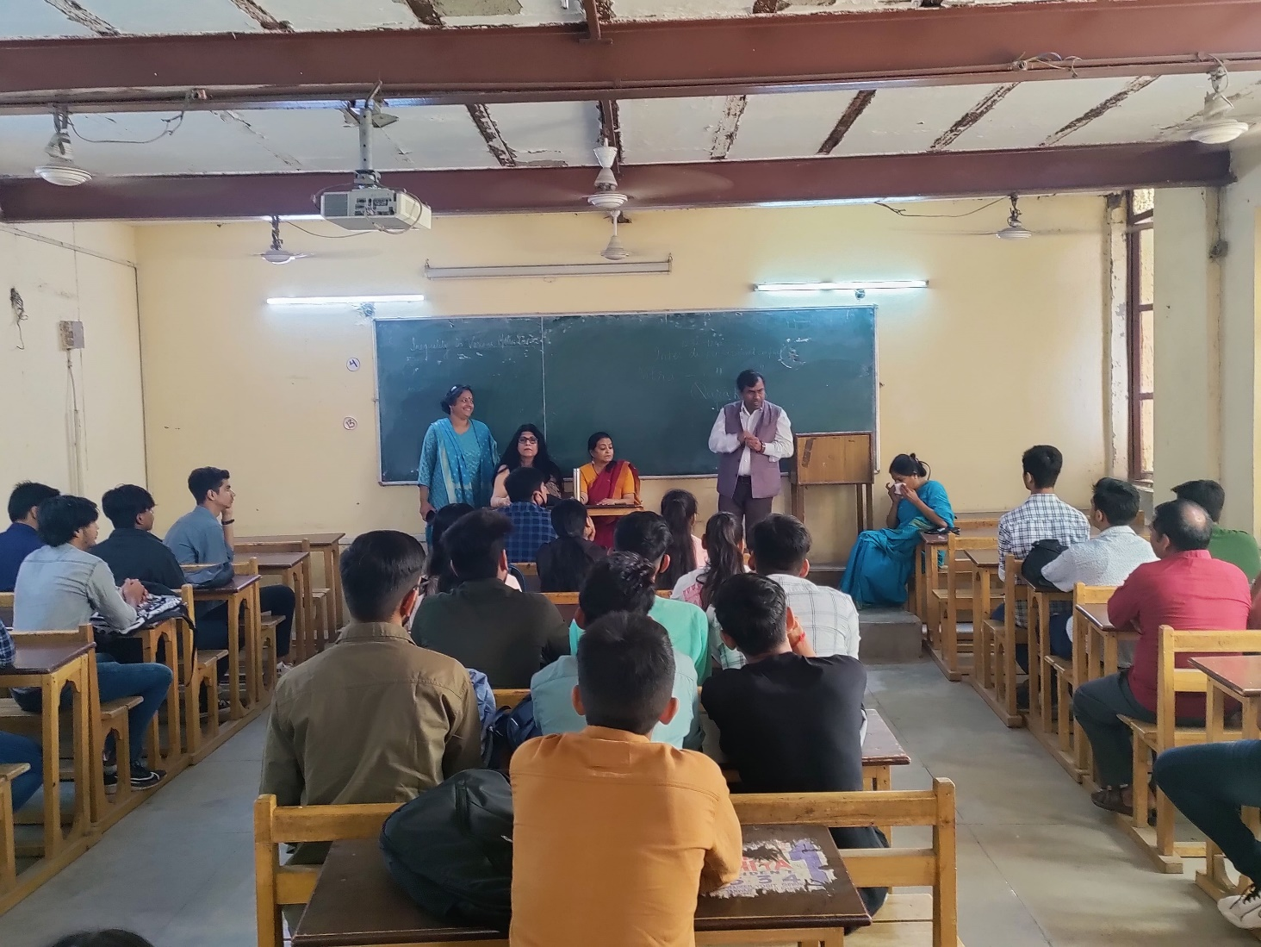

REPORT
Seminar on The French Revolution
NOVEMBER 11, 2022

Professor Vasudha Pande, an expert on the history of Modern India and Modern Europe deliberated on the background, historiography and the role of various estates and especially of women in the revolution. Speaking on the various facets of the revolution, she enlightened the audience about the political, social and cultural impact of the upheaval in France and the rest of the world. The History
Faculty member along with approximately eighty students from all three years attended the seminar.
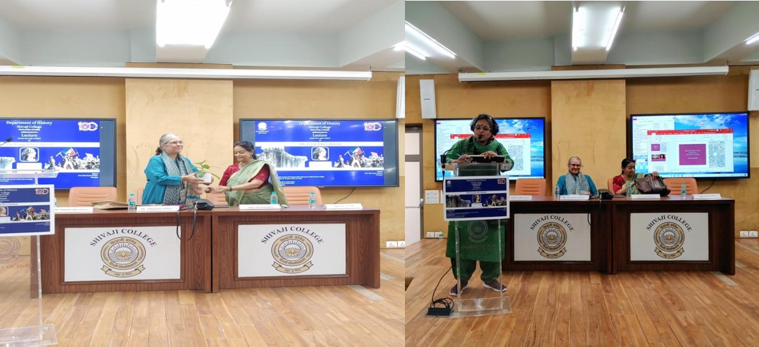
The lecture was followed by a question answer session which provided an opportunity to the students to develop a comprehensive understanding of the theme.

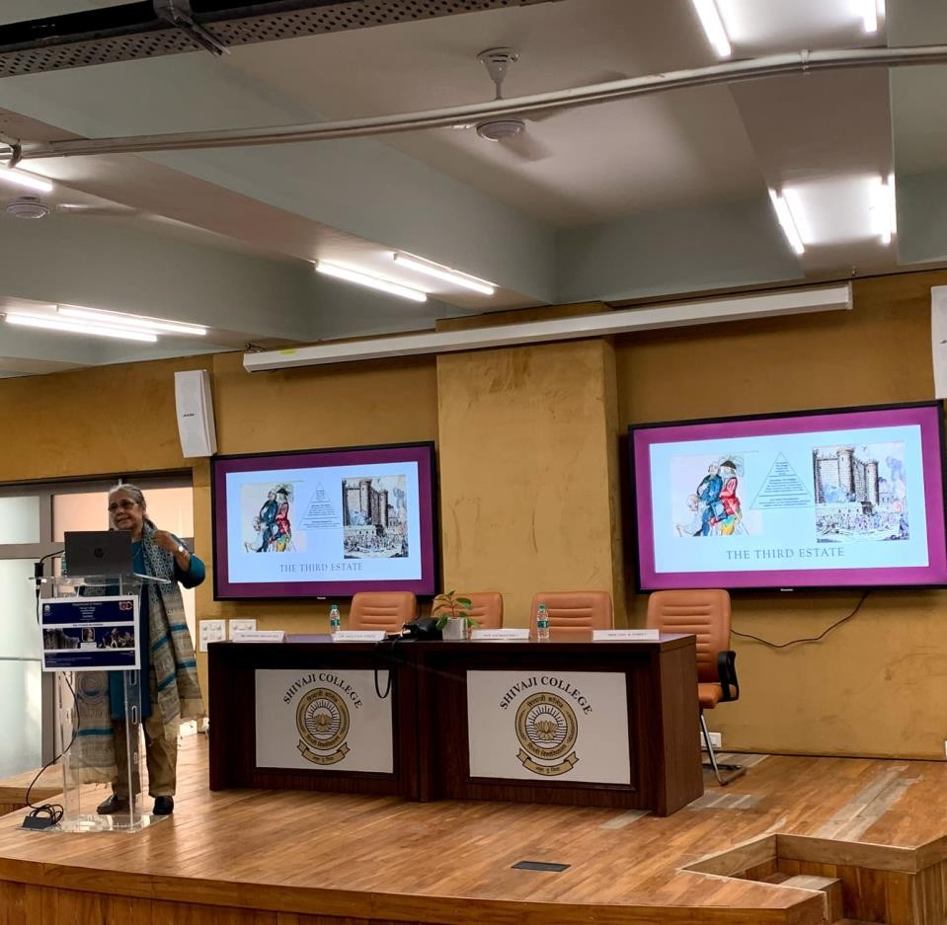

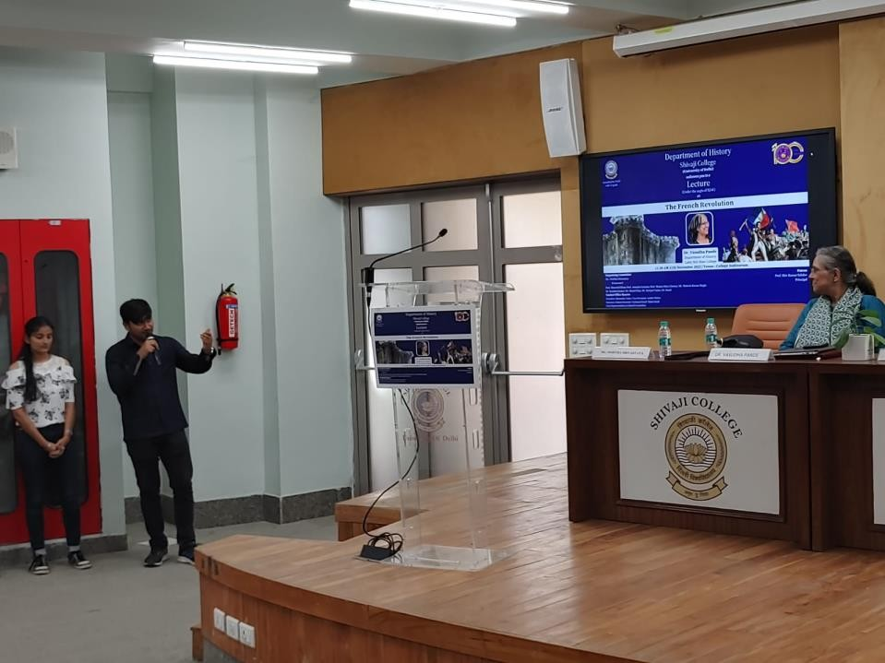
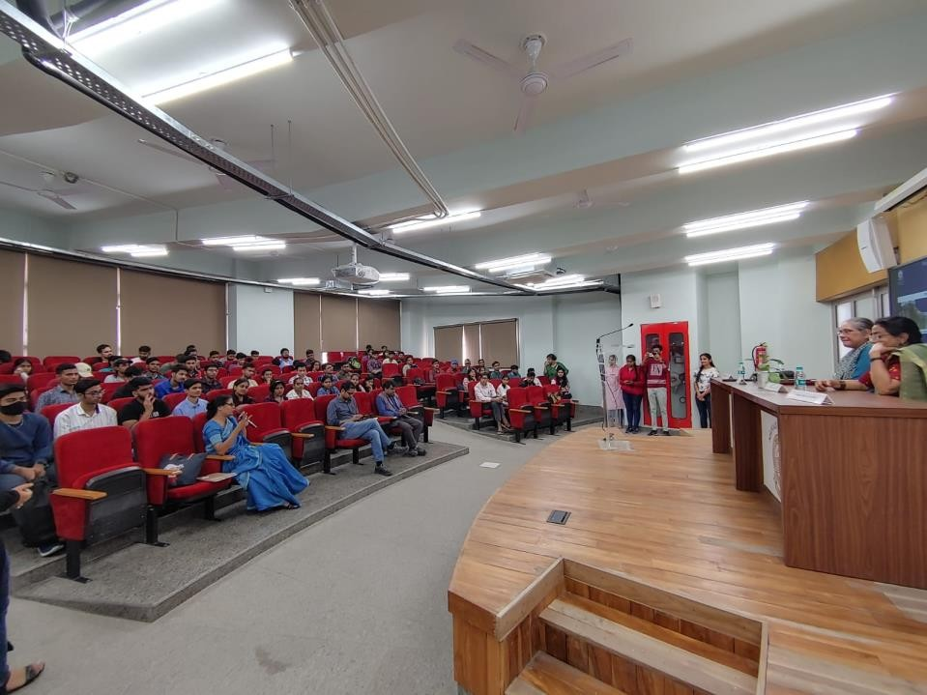

REPORT
HERITAGE WALK – Qutb Complex and Mehrauli Archaeological Park
November, 22, 2022

The faculty in its effort to provide experiential learning to students, organised a ‘Heritage Walk’ to the above sites. The walk was primaryly conducted by Prof. Shama Mitra Chenoy, with valuable additions by the other faculty members from time to time. Prof. Chenoy began with an account of topographical features of Mehrauli in the 13th and the 14th century and delved on the history, architectural features and techniques of the various structures in the Qutb complex. Thereafter the group visited the tomb of Jamali Kamali, the nearby Rajon ki Baoli and learnt about the unique architecture of Baolis and their importance as sources of water and sites for cultural interaction. The walk concluded with visits to tomb of the Sufi saint-Qutb ud-din Bakhtiyar Kaki and the adjacent Zafar Mahal. 150 students participated in the heritage walk. It was a learning experience for them, providing an opportunity for everyone to get know each other better.

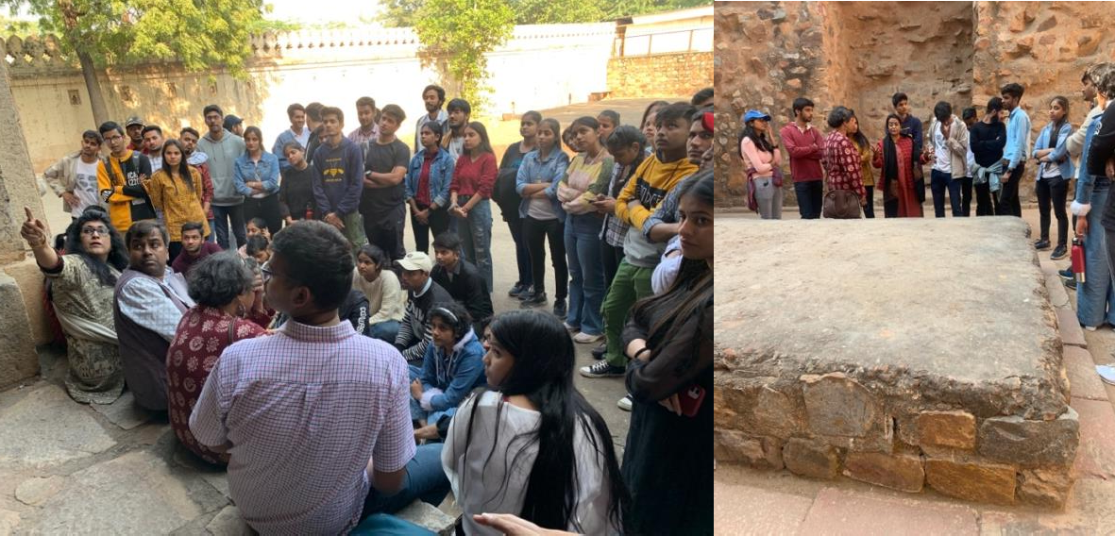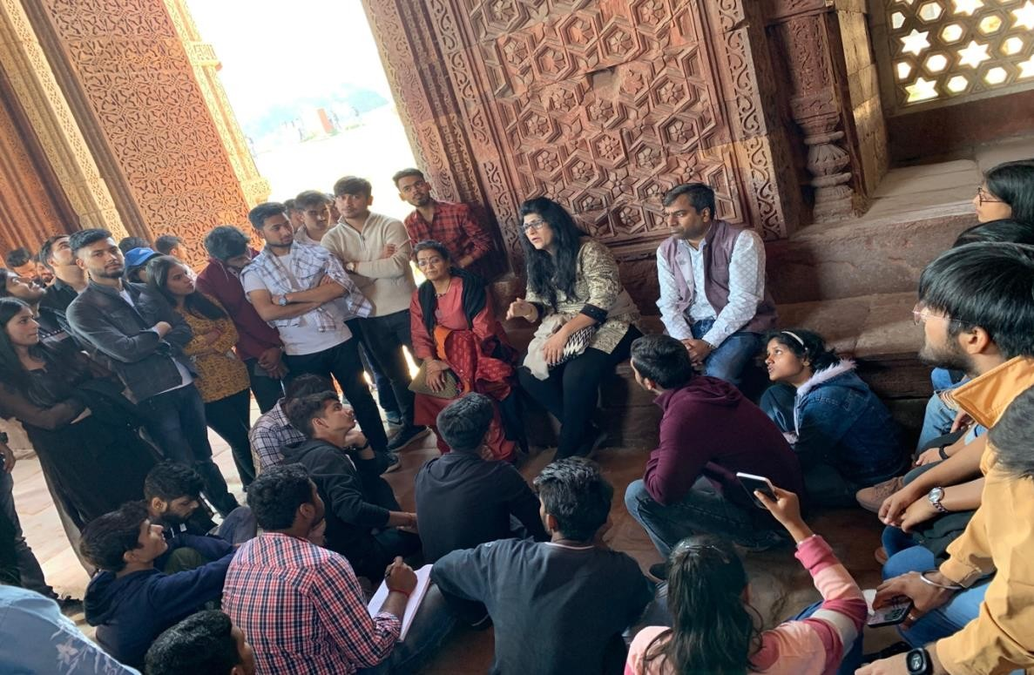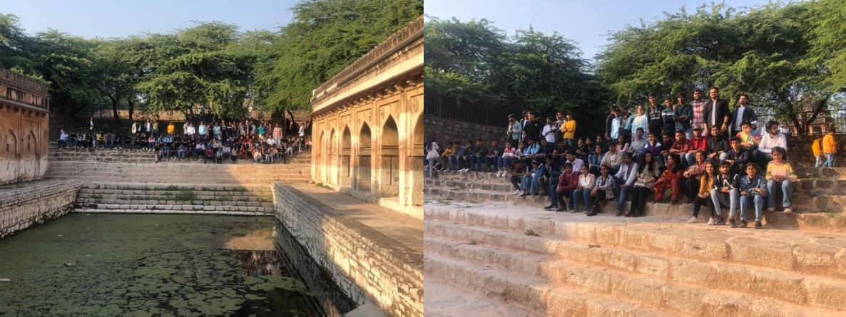

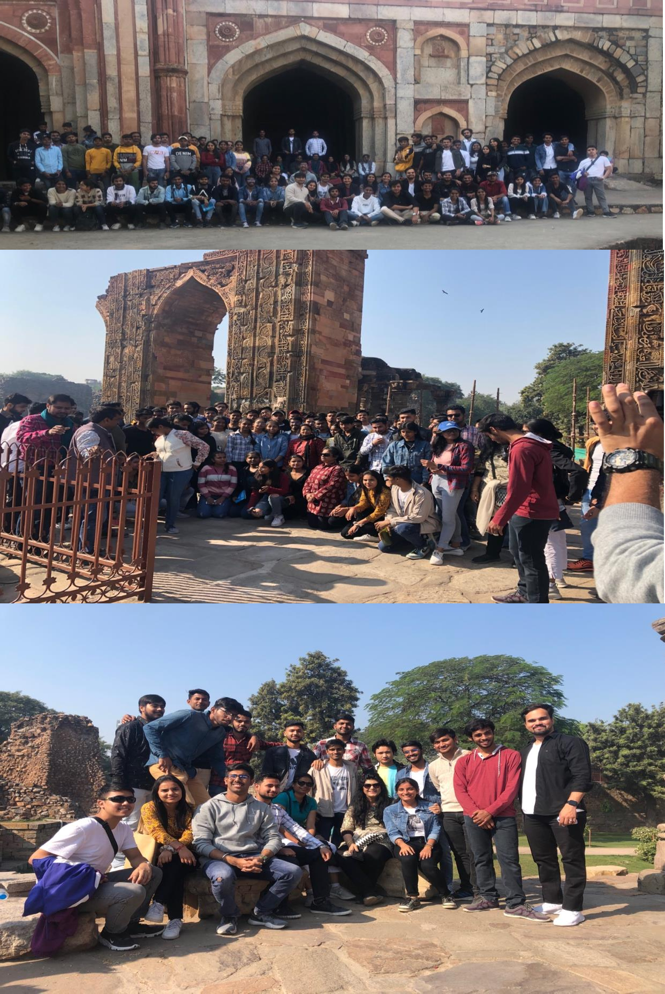

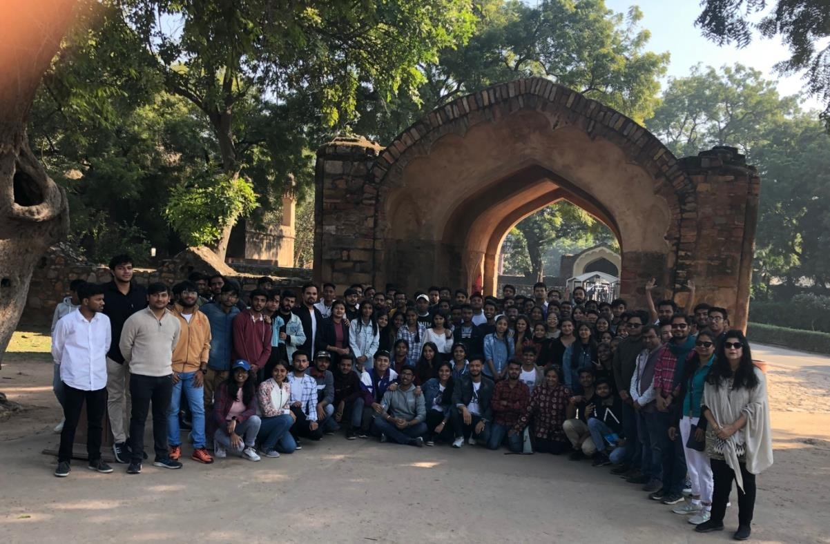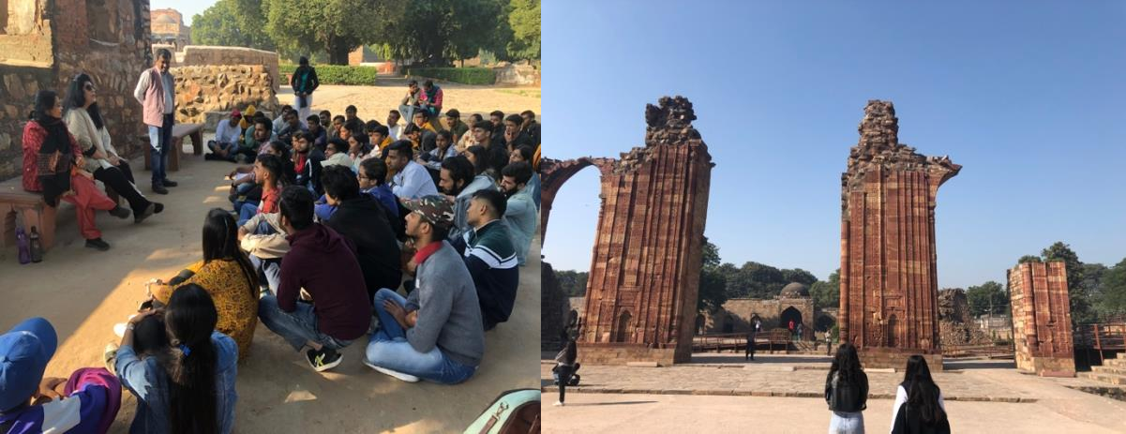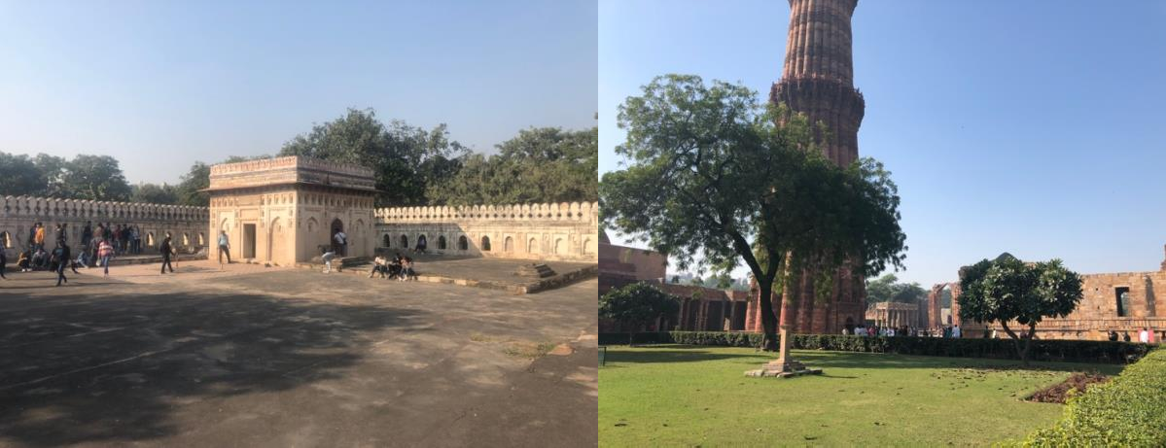

REPORT
Seminar on Indian Princes and Imperial Darbars
April10, 2023

Professor Amar Farooqui from the History Department, University of Delhi, shed light on the various princely states and confederacies that existed under the British rule in India in the 19th century. Speaking about the various Imperial darbars held during the regime, he emphasized on the existence of hierarchy among the states signified by the number of cannons shot that a ruler of a state was entitled to. Prof. Shama Mitra Chenoy chaired the session. The deeply insightful lecture was attended by numerous students and faculty. The audience responded to the talk by addressing their curiosity and doubts to the speaker.
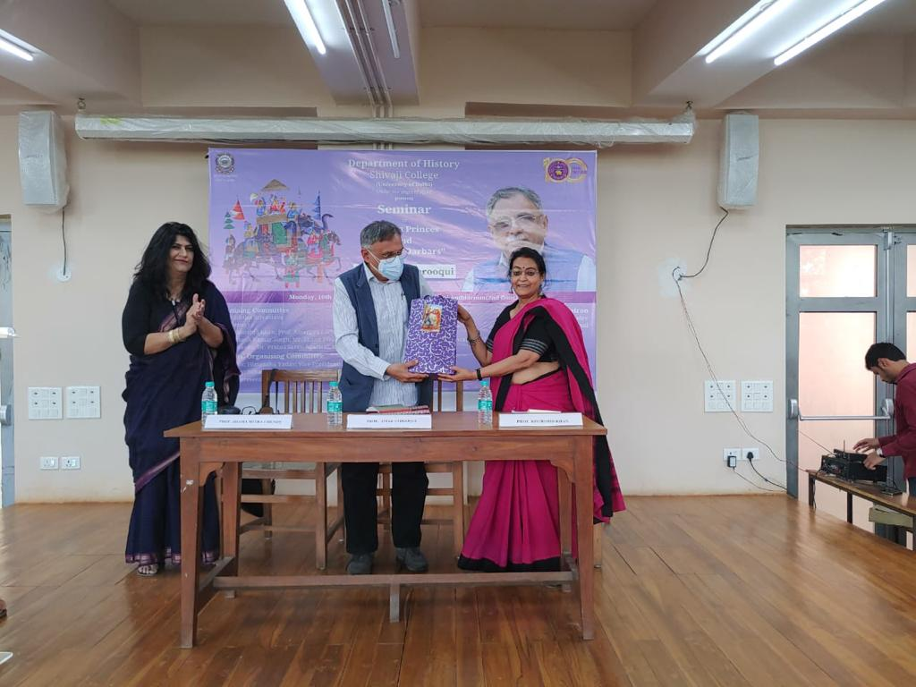

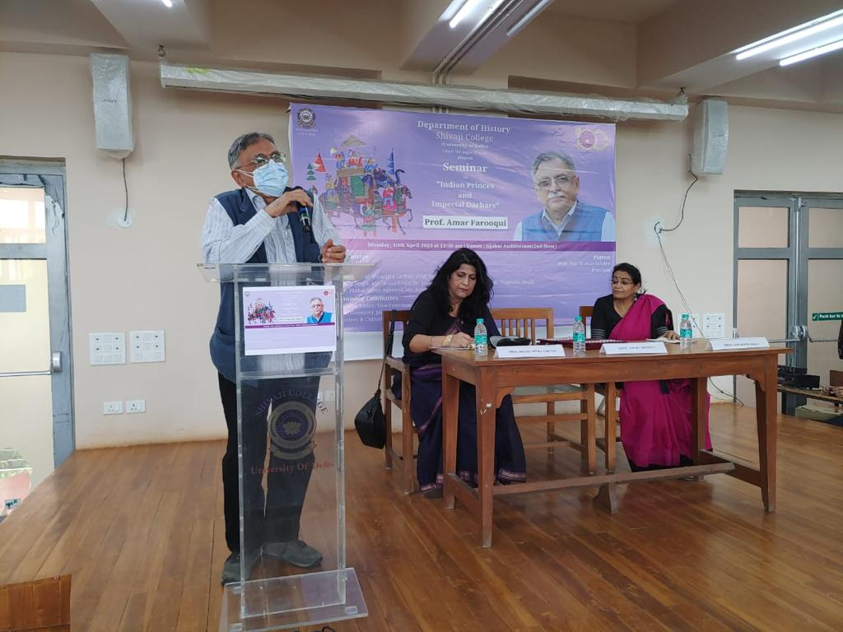

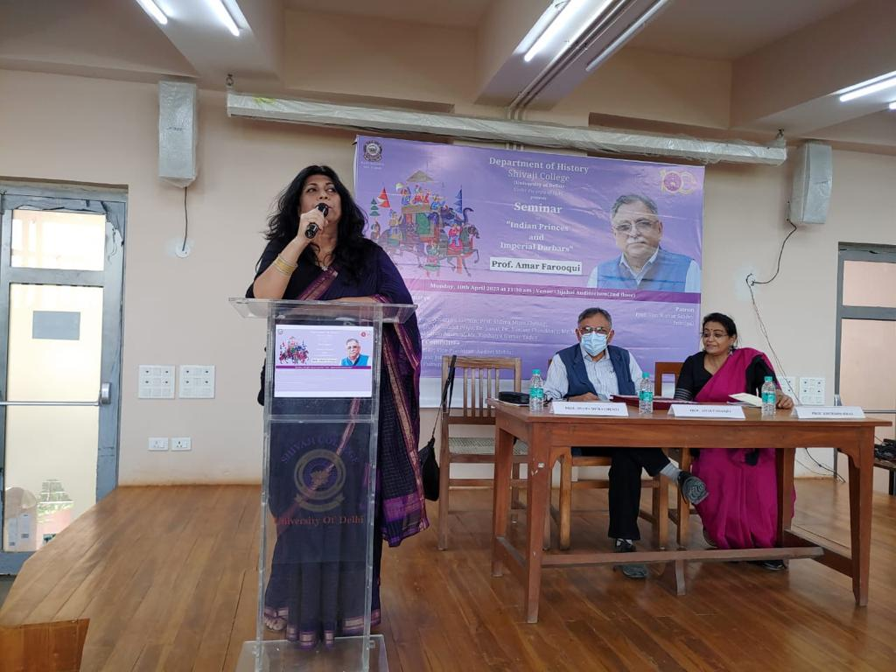

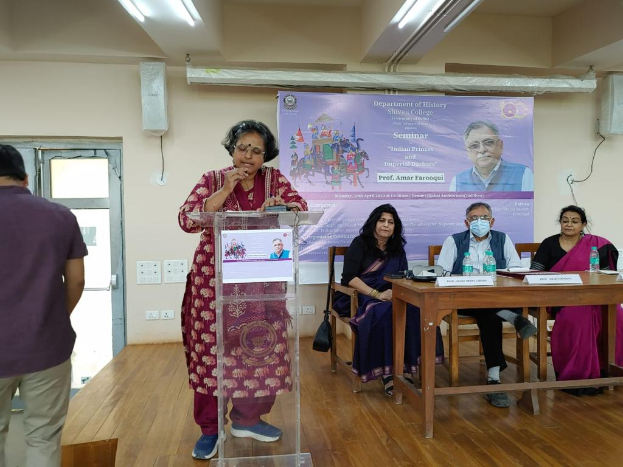

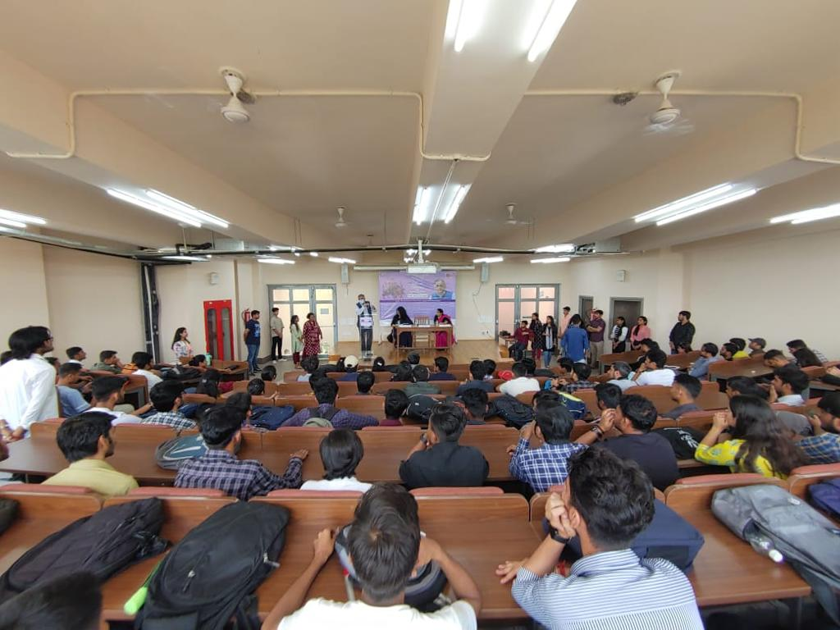

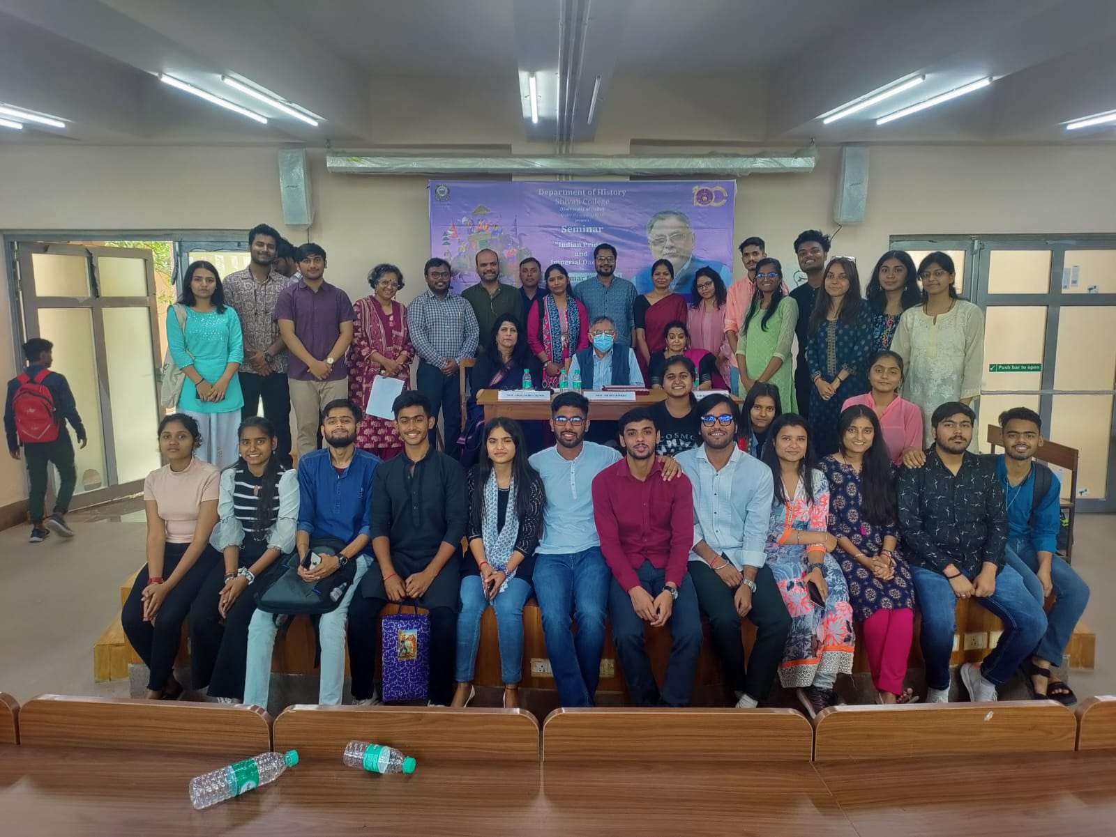

REPORT
COMPETITIVE EVENTS 2023
12th April 2023

The History Department organised a series of competitions, painting, character play and a film review. On the spot painting competition was on cultural diversity in India and global environmental. In the character play, the participants embodied and enacted historical figure like Vivekananda, Sarojini Naidu, Savitri Bai Phule and Mirza Ghalib. “The Elephant Whisperers” was screened for the film review competition. Large number of students participated enthusiastically in all the events and won prizes. These competitions allowed students to showcase their skills and learn from one another.

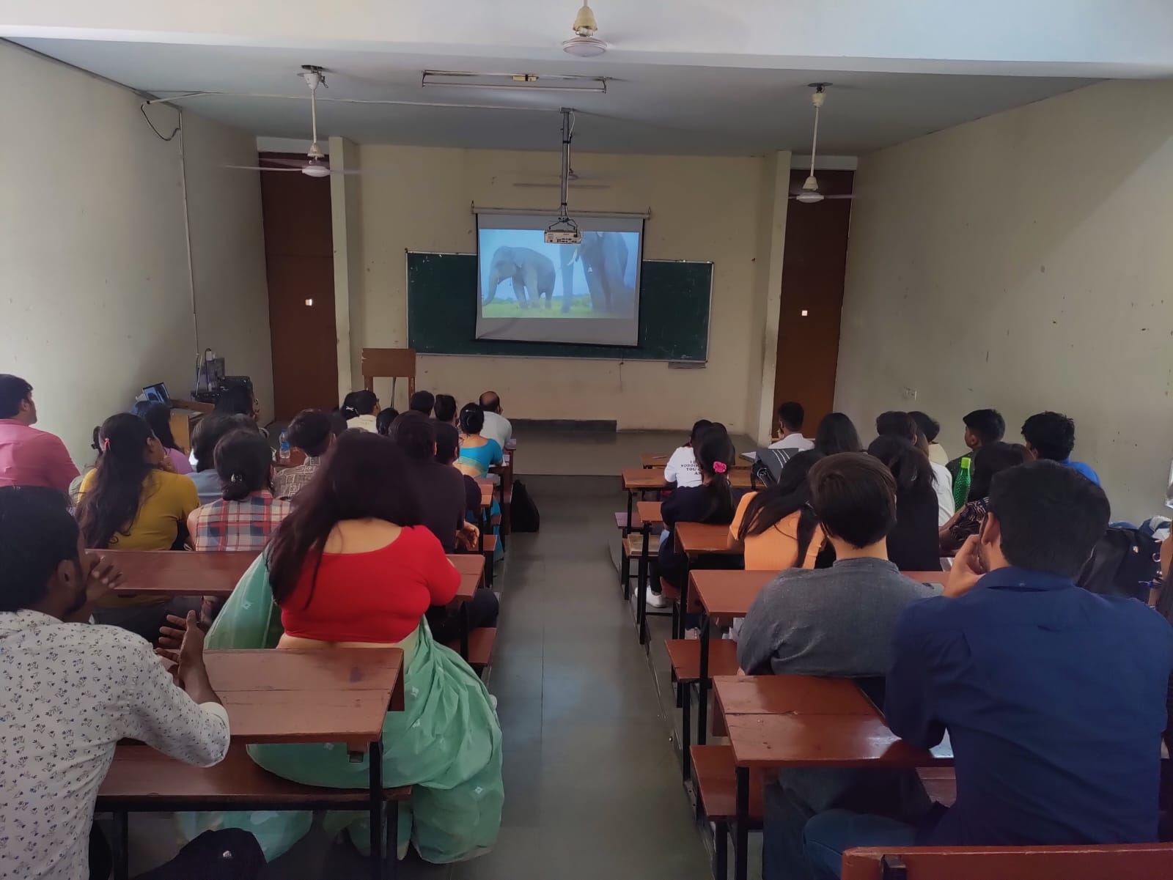

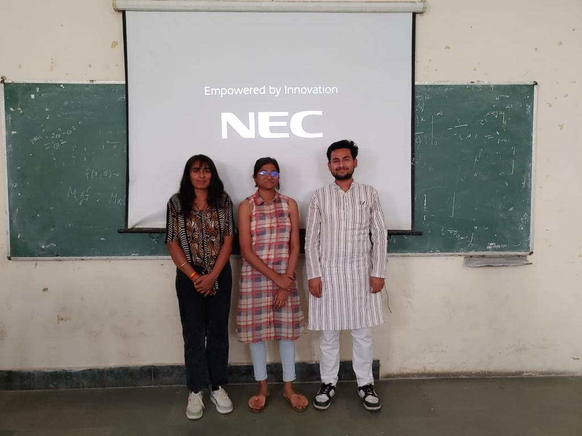

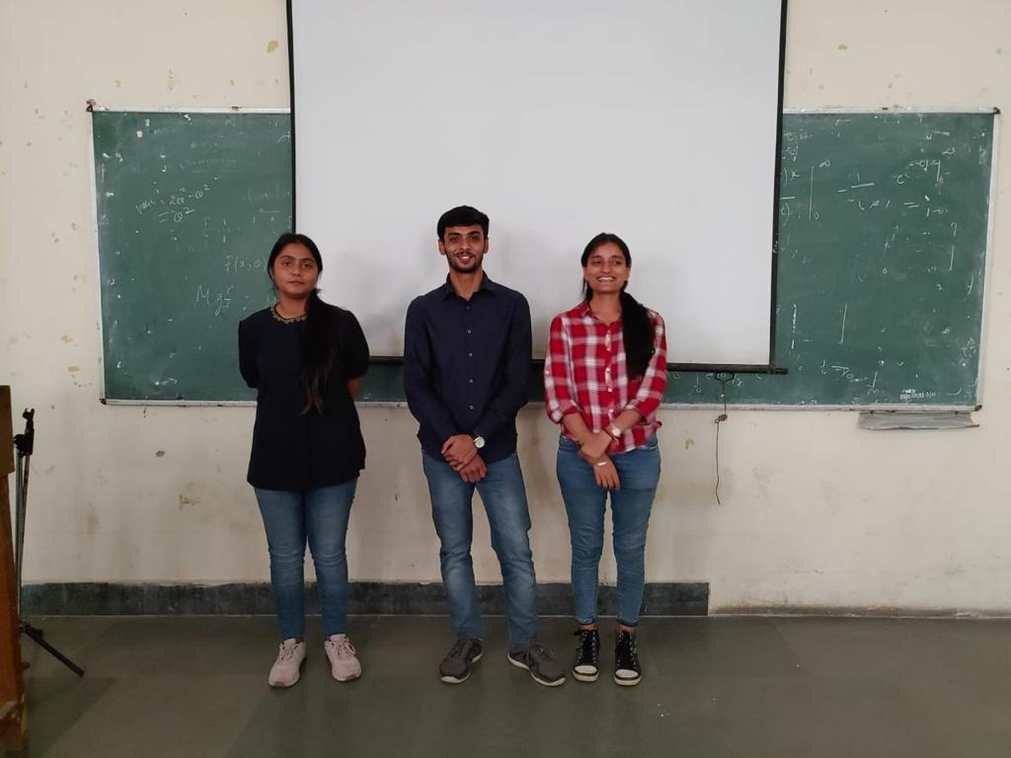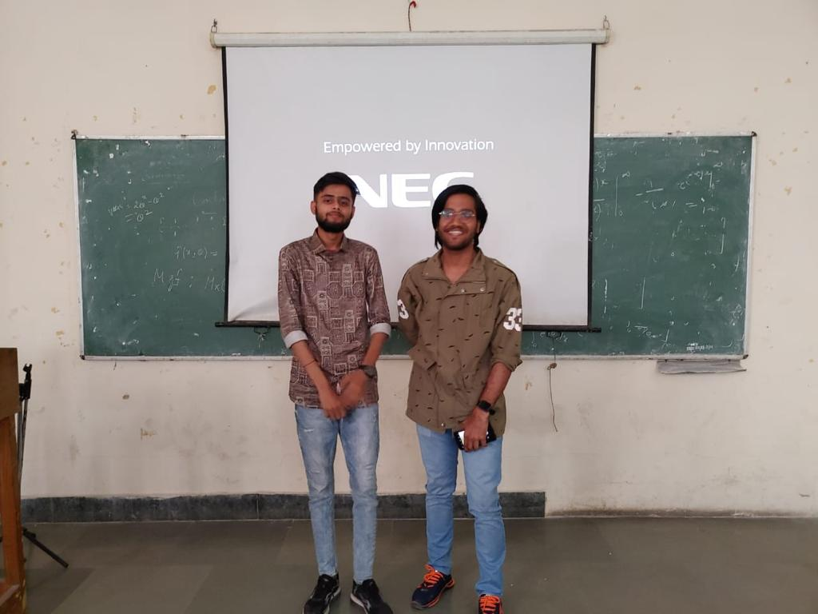

EVENT REPORT
HISTORICAL EXCURSION TO JAIPUR AND AJMER
FEBRUARY 19-21, 2023

As a part of experiential learning, the department organized a historical tour to Jaipur and Ajmer. Thirty-four students and six teachers were part of the excursion. On 19th February, the team visited City Palace, Jantar Mantar and Hawa Mahal in Jaipur, the capital of the Kachhwahas built by Sawai Jain Singh. The next day they went to the dargah of Shaikh Muin ud-dīn Chishtī and the Adhai din ka Jhopda in Ajmer. On 21st morning after touring the Amer palace fort complex and the Albert Museum (in Jaipur), the group returned to Delhi.

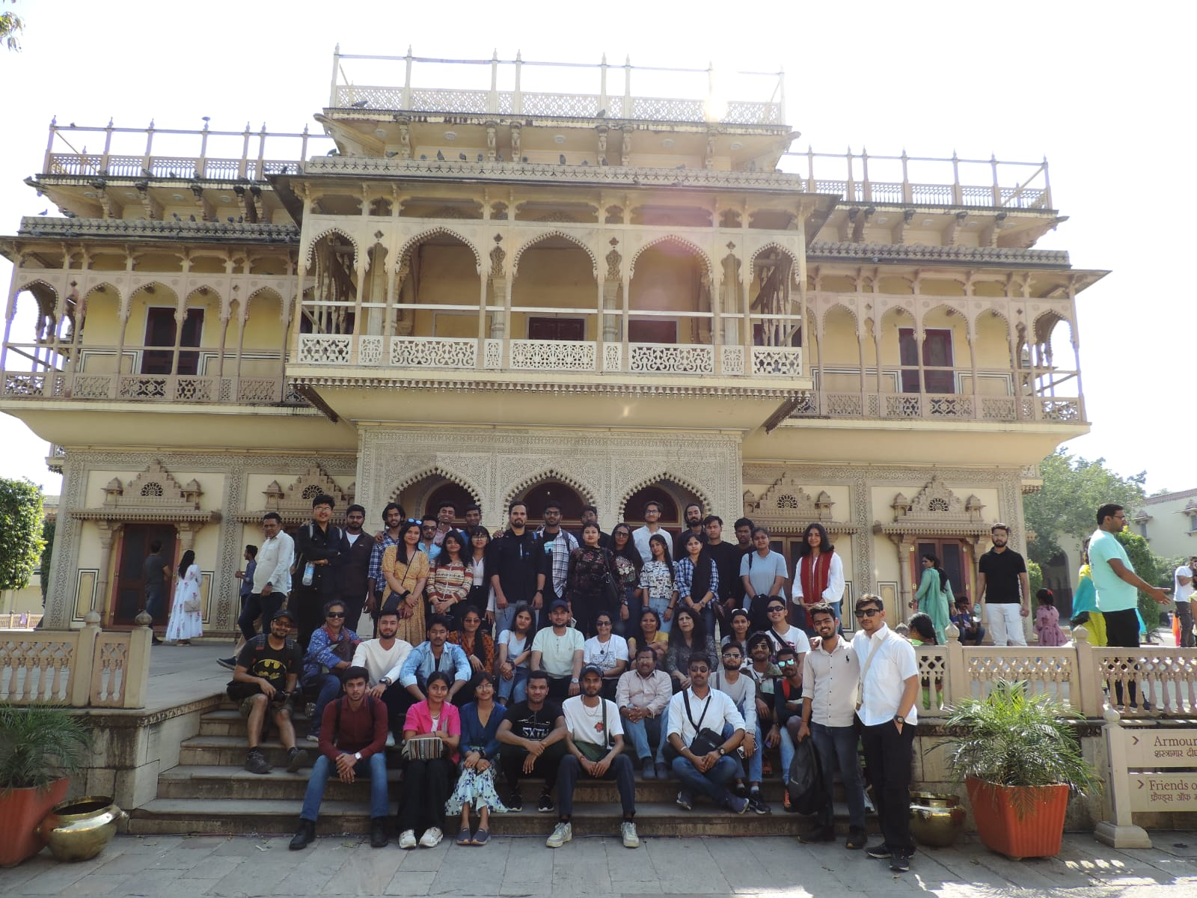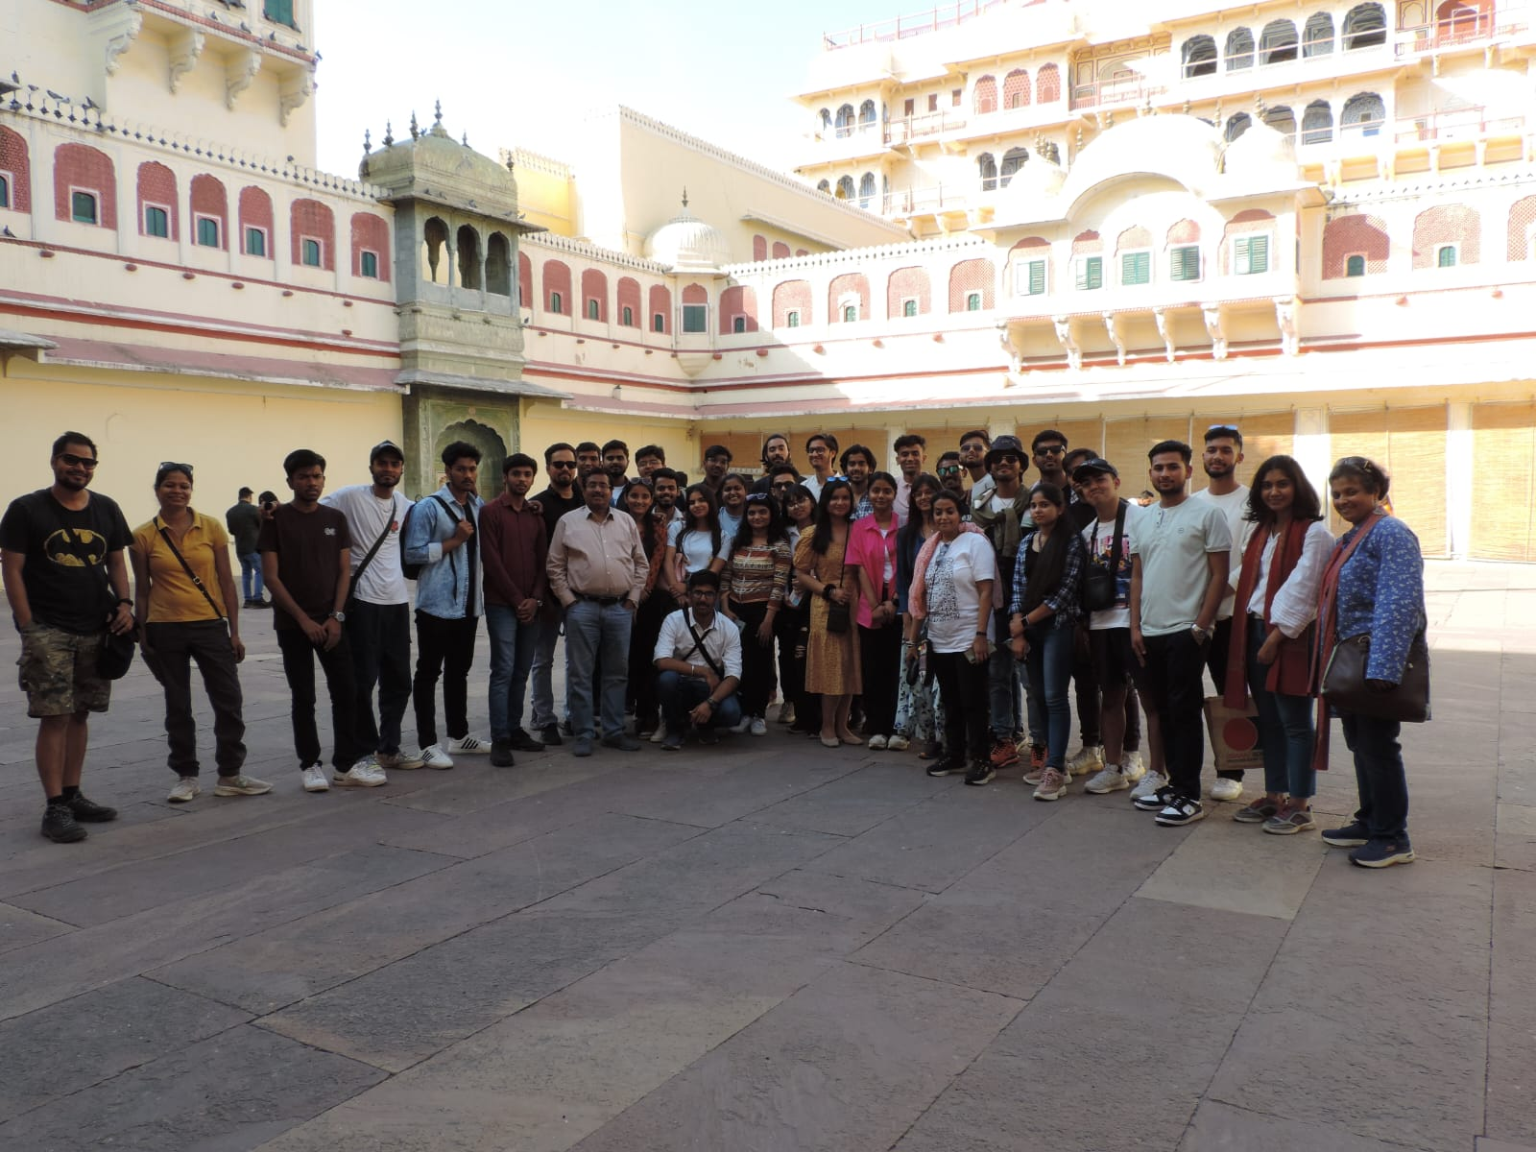

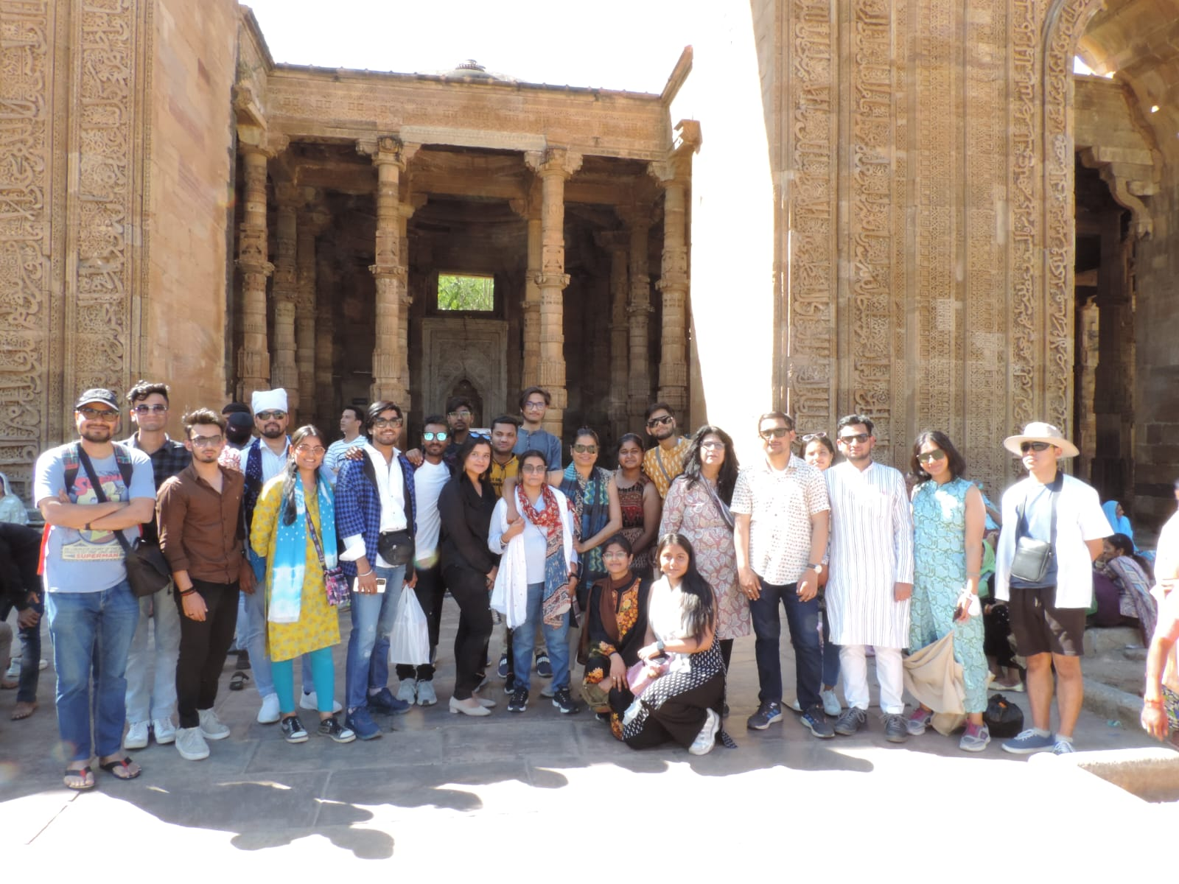

EVENT REPORT
ALUMNI MEET
APRIL 6, 2023

In continuation with the regular practice of holding annual alumni meets, the department organized a virtual alumni meet via zoom platform.

